

|  |  |
| --- | --- |
| **C2110I – eProject 3 – Insurance**  **[Group 2]** | |
| **Member Group** | **Bach Tran Xuan**  **Hung Nguyen Huu**  **Tho Nguyen Duc**  **Anh Nguyen Duc Nhat**  **Quyen Luu Trinh** |
| **Date** | **04-May-2023** |
| **Instructor** | **Hoang Nguyen Duc** |

**- APTECH 2023 -**

**Table Of Contents**

**1. Problem Definition**:

1.1 Problem Solving

1.2 Requirements And Restrictions

1.3 Solution

**2. Customer Requirement Specification:**

2.1 Customer's Request

2.2 Interface Information

**3. Project Plan:**

3.1 Implementation And Management

3.2 Information About The Plan

**4. E-R Diagrams:**

4.1 Database Design

4.2 Analysis

**4.3 Site Map.........................................................................................................................**

**5. Algorithms:**

5.1 Algorithm Definition

**6. GUI Standards Document:**

6.1 Interface Design Standard Definition

**7. Interface Design Document:**

7.1 Interface And Component Requirements..........................................................

8. Screen Shot's:................................................................................................................

**1.Problem Definition.**

**1.1_Problem Solving**

The project provides online insurance services that include four types of insurance: life insurance, medical insurance, motor insurance, and home insurance. The problem to be solved for this project is to create an online system that allows customers to view and update information on various insurance packages offered by the insurance company, register for new accounts to access online information, and calculate insurance premiums for existing policies. In addition, the project also needs to provide information on new strategies and subsidiary programs of the insurance company, provide loan services for policyholders, and support online payments. For life insurance, customers need to pay monthly insurance premiums for a certain period of time to be financially protected in case of any risks.

To solve the above problems, we were provided with valuable and necessary professional knowledge by the teachers at Aptech to carry out a project assigned by HO. The 3rd semester project is a good opportunity for us to synthesize and perfect our knowledge. This project has given us valuable and practical experiences. During the process of making this project, we received a lot of help from the instructors. Finally, we would like to thank Mr. Nguyen Duc Hoang for supporting us. Sincerely thank you!

**1.2_Requirements And Retrictions.**

*Requirements:*

- There must be an online system that allows customers to view and update information on different insurance packages offered by the insurance company.

- There must be a feature to register new accounts for customers to access information online.

- There must be a feature to calculate insurance premiums for the customer's current policy.

- Provide information on new strategies and sub-programs of the insurance company.

- Provide loan services for policyholders and support online payments.

*Restrictions:*

- The project only provides online insurance services for 4 types of insurance: life insurance, health insurance, car insurance, and home insurance.

- The project only supports calculating insurance premiums for the customer's current policy, not for new policies.

- The project only provides information on new strategies and sub-programs of the insurance company, not personal insurance advice.

The project only provides loan services for policyholders, not personal loans for others.

**1.3_Solution.**

Based on the project requirements provided, some possible solutions for the Insurance-services project are:

- Develop a user-friendly website that provides easy access to information about different insurance policies, their features, benefits, and premium amounts.

- Enable users to register on the website to create their profile and get information about insurance policies and schemes offered by the company.

- Implement a feature that allows existing policyholders to view their policy details and calculate the premium based on the term plan they have taken.

- Provide up-to-date information about new strategies and subsidiary schemes of the company, including any changes in premium amounts, benefits, or terms and conditions.

- Ensure the website and app are secure and comply with data protection regulations to protect users' personal and financial information.

- Provide prompt and efficient customer service to resolve queries and concerns related to insurance policies, claims, and payments.

By implementing these solutions, the Insurance-services project can provide comprehensive and efficient insurance services to its customers, increase customer satisfaction, and ultimately grow its business.

**2. Customer Requirement Specification**

**2.1_Customer's Request.**

The requirements and expectations of customers for a project may include:

- Website should be easy to use and access: Customers want a website that is user-friendly, easy to use and can be accessed anytime, anywhere to find insurance information and services.

- Quality requirements for products or services that need to be met to satisfy customer needs.

- Time requirements for project completion to meet business or market demands.

- Cost requirements for the project to ensure it remains within the customer's budget.

- Desires for the features and capabilities of the product or service to meet specific customer needs.

- Desires for technical support or after-sales services to ensure the product or service can be used and maintained effectively after deployment.

- Desires for the reliability and security of the product or service to ensure the customer's data and information is protected and safe.

In summary, in this project, customers want to have a high-quality, safe, convenient and fast online insurance service to ensure that they will be best protected in the event of any accident any risk.

**2.2_Interface Information.**

**Function:** This project offers four types of insurance services including Life Insurance, Health Insurance, Vehicle Insurance and Home Insurance. The project is currently online, allowing company officials to view and update information. Features of Online Insurance Services include:

- Users can view information about policies and plans offered by the Insurance Company.

- New users can register with the site to receive information online.

- Existing policy owners can view their policy details and calculate fees.

- The website provides information on the company's new strategies and sub-plans.

- Provides the ability for policy holders to borrow and pay online.

**Efficiency:** The project has performed well, providing diversified insurance services such as life insurance, health insurance, auto insurance and home insurance. Users can view information about policies and service plans offered by insurance companies, register and calculate premiums online, and can get the latest information on strategies and plans company's sub-program. The project also offers the ability to borrow money for policy holders and pay online.

**Reliability:** The reliability of the online insurance project depends on the security measures implemented to ensure that customer information is protected and safe. In addition, the features and quality of the software also play an important role in the reliability of the project.

Reliability is an important element of an online insurance project. The system must ensure the integrity of customer data, ensuring that their personal information and accounts are protected from security threats.

**User Interface:** The user interface of the above project will have features that will allow users to view and update information about policies and plans, sign up for new accounts, view details about existing policies and insurance premium calculation. Additionally, the user interface provides information on the insurer's new strategies and plans, allows users to make online payments, and provides loan services to policy holders.

The user interface of the project uses a simple, easy-to-use and user-friendly design. It includes interactive buttons and clear menus, making it easy for users to access and find information about insurance services. The interface is optimized for mobile and tablet devices, ensuring a good user experience on any device. In addition, the interface is also designed to meet high security standards, protect user information and ensure privacy.

**3. Project Plan**

**3.1_Implementation & Management.**

To implement this project, it is possible to use Agile methods for software development. The development team will divide the work into small sprints and perfect each part continuously. After that, the product will be tested and tested before rolling it out publicly to users. Implementation of the above project can be done through cloud servers or delivered directly to user computers.

For project management, we have divided the content and work to be done of the specific project for each member as follows. Our project will have 5 parts: Project Management, Analysis, Design, Code, Test. To know more about members' information and work, read on below:

- ***Project Managerment***: Regarding project management, my team will nominate Bach Tran Xuan (leader) to be in charge of this issue. Bach will do tasks such as: Project Planning, Resource Management, Time Management, Progress Management, Risk Management, Team Member Support,... To get a good result.

- ***Analysis***: This is the first part of our team's project management process, in this part, everyone in my team will come up with ideas, analyze things in the project to prepare for the next step.

**-** ***Code***: This is the step that can be considered the key part of the project. Before coding, my team had to think a lot to form a complete code. Make our project more and more complete and clean. In this part, there are friends Nhat Anh Nguyen Duc, Tho Duc Nguyen is responsible for practice. In addition, this Code section also has support from the team leader, to help you perform better. Bring a beautiful and standard Code part.

***- Test***: Testing is the last step present in our project management process, a meticulous test that can assess a project is good or not. In this section, our team selected two capable people to perfect it. In this part, Hung Nguyen Huu and Quyen Luu Trinh will perform. We have planned the tests, executed the tests, checked the features of the software, automated the tests to find the bugs and complete our project better.

The division of work and project members is an important step to ensure the progress and efficiency of the project. We have carefully considered and selected members with the right experience and skills to take on the tasks in the project. At the same time, dividing the work into specific stages also helps us to optimize the time and resources of the team. We believe that with such division and collaboration, the project will be completed on schedule and to the expected quality.

**3.2_Information About The Plan.**

Some information about the project schedule, resources and people.

* **Week 1:**

The first week will be spent planning and setting goals for the project. Team members will begin researching and researching the project, along with developing a detailed work plan for project implementation.

* **Week 2:**

Start implementing and implementing the project, dividing the work among team members. Members will continue to learn and research on issues related to the project.

* **Week 3:**

Continue to deploy and implement the project, ensuring the work progress. Members will focus on performing their jobs, according to the set work plan.

* **Week 4:**

Complete the remaining work and ensure the project is completed on time.

Perform inspection, maintenance and debug if necessary.

Possible risks in this project include failure to complete tasks on time, failure to complete tasks with quality or failure to meet customer requirements. To avoid this risk, careful and precise discussion, planning and work assignment is required.

**4. E-R Diagrams**

**4.1_Database Design.**

Database Design Image

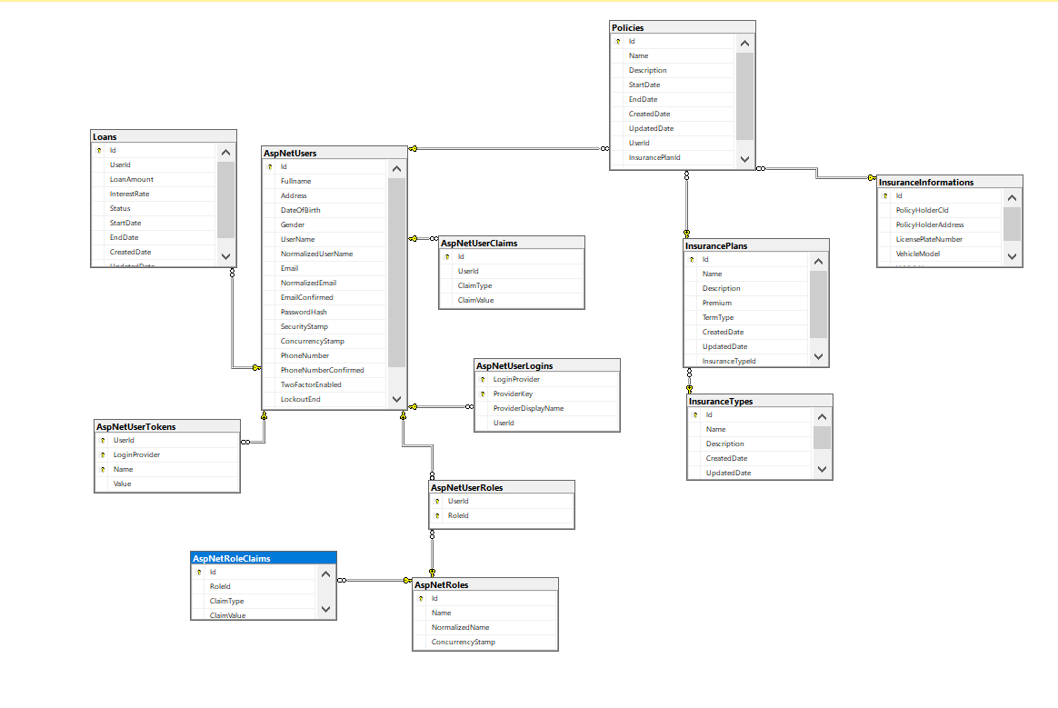

On the database table we have information fields such as: Policies, Loans, AspNetUsers, AspNetClaims, InsurancePlans, InsuranceInformations, AspNetUserTokens, AspNetUserLogins,...

The above fields help us ensure data security, concurrent access, and easy project management. It has an important role in the software industry with its ability to create expertise in working with software that has always been clearly distinguished.

**4.2_Entity Relationship Diagram.**

Entity Relationship Diagram Image

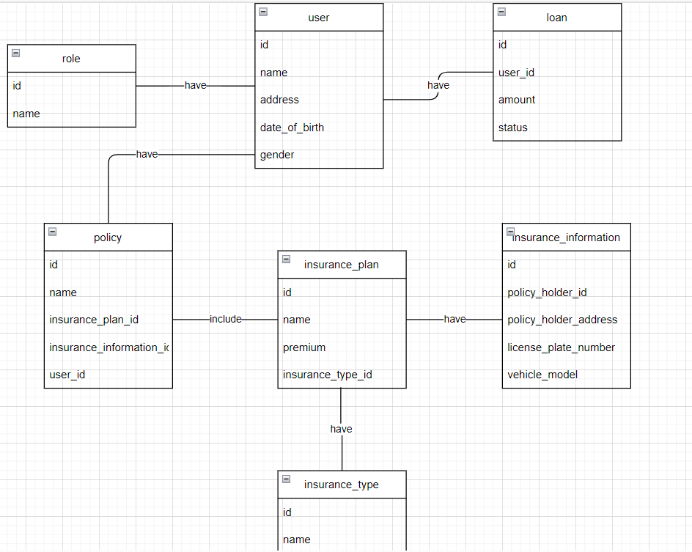

**Detailed Description:**

- Table insurance_type: contains different types of insurance, for example health insurance, car insurance, home insurance.

- Table insurance_information: contains information about the customer's insurance, including the name, start date, end date, insurance amount, corresponding insurance code, and customer ID.

- Table insurance_plan: contains different insurance plans, for example basic insurance plan, advanced insurance plan.

- User table: contains information about the user, including the user's login name, password, full name, email address, phone number, and role ID.

- Role table: contains different roles a user can have, for example customer, administrator.

- Loan table: contains information about the customer's loan, including loan amount, interest rate, term, start date, and customer ID.

Above is a specific description of our team's ERD. The components are described in detail and clearly, making it easy for readers to recognize and understand each function in the ERD.

**4.3_Site Map.**

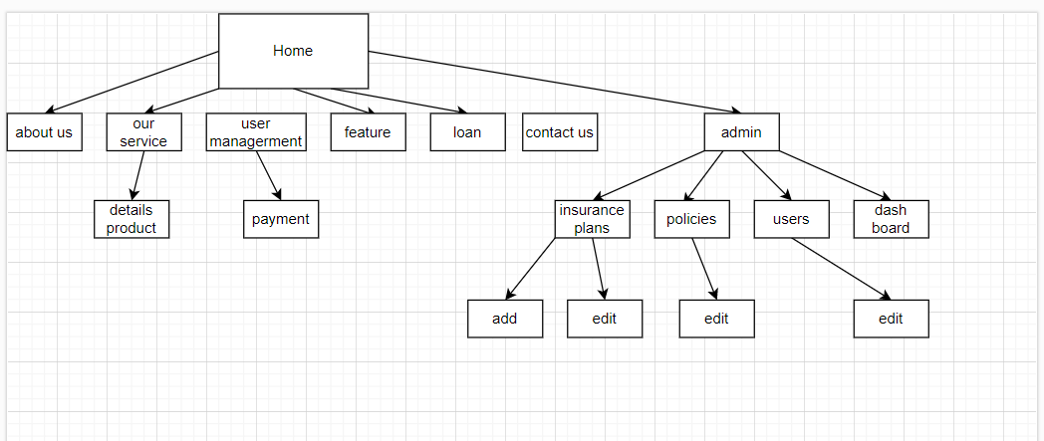

A sitemap is a site map that helps users find content and information on a website easily. It provides an overall display of web pages, links, and site structure to users.

Sitemap makes it easy for users to understand the site structure and find web pages quickly. It also aids in search engine optimization (SEO) by helping search engines understand a website's content and links between web pages.

Sitemaps are often designed with a simple, easy-to-use and intuitive interface to help users find information conveniently. It is usually placed in the footer of the website or a special link is placed in the header to lead to the sitemap page.

**5. Algorithms:**

**5.1_Algorithm Definition.**

In this project, there are many algorithms we use, which can be mentioned as:

- Sorting algorithm: helps to sort the elements in a list or array in ascending or descending order.

- Search algorithm: helps to find a specific element in a list or array.

- Graph algorithms: help build and manage graphs to find shortest paths, or to solve other graph-related problems.

- Encryption algorithm: helps to encrypt and decrypt information for security.

- Machine learning algorithms: help identify relationships between features and labels to predict future outcomes.

- Natural language processing algorithms: help analyze and process information in natural text.

- Optimization algorithm: helps to optimize the objective functions and find the optimal values for the variables.

- Reinforcement learning algorithms: help computers learn how to perform actions to achieve a specific goal.

Currently, our project will use these algorithms to complete. In the future, when we expand the project, there may be more new algorithms, supporting customers when using our services!

**6. GUI Standards Document:**

**6.1_Interface Design Standard Definition.**

Our project's user interface (GUI) design standards will include the following elements:

- Intuitiveness: The GUI should be designed so that the user can easily interact with the interface, and easily see and read the information on the screen.

- Compatibility: GUIs need to be designed to work well across different platforms, devices, and browsers.

- Consistency: The GUI should be designed so that its elements have the same style, color, and arrangement to create a unified user experience.

- User-friendliness: The GUI should be designed to meet the needs of the users and help them feel comfortable and confident when using the project's services.

- Security: The GUI needs to be designed to ensure the safety of user information and prevent outside attacks.

- Usability: The GUI should be designed to meet the needs of the target audience and be easy to use, even for those with no technology experience.

**7. Interface Design Document:**

**7.1_Interface Design Standard Definition.**

To define the requirements for the user interface and the components associated with the project system, the following information may be included:

- User interface requirements: must arrange and arrange elements on the user interface to ensure aesthetics and user-friendliness. Include resolution, contrast, font size, color and image requirements.

- Requirements for components associated with the system: These are requirements for additional components to the system to ensure completeness, efficiency, and security. Includes requirements for data integration, interoperability with other systems, security, and access management.

- User interaction requirements: These are requirements for how the user interacts with the system, including simple operations such as click, drag and drop, as well as more advanced operations.

- Responsive design requirements: These are the requirements for responsiveness of the user interface on various devices, including laptops and mobile phones.

All of these requirements are designed to ensure that the user interface and the components associated with the system fully meet the needs of the user and meet the technical requirements of the project.

**8. Screen Shot’s:**

**1_Login Page:**

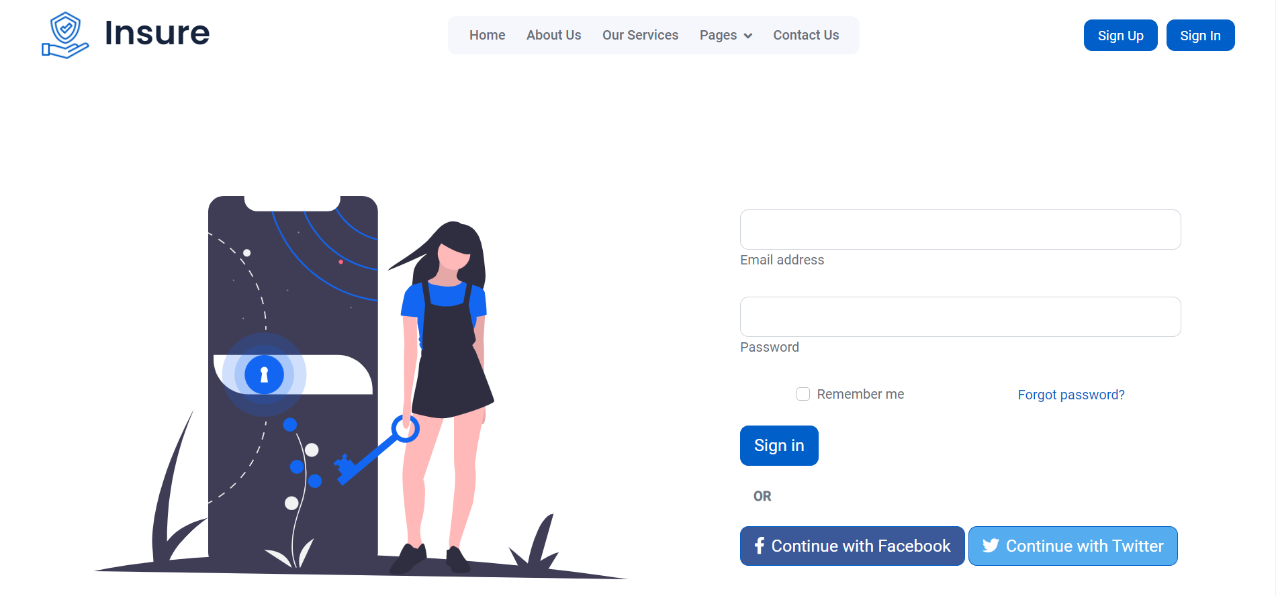

The login page is an important part of most websites, allowing users to access their accounts. It requires the user to provide the correct login information and provides other options such as authentication codes or security questions for security. If the credentials are correct, the site allows the user to access their account and redirects them to the page or feature they requested. In addition to login information, the login page may also provide other options such as "Remember Login". If the credentials are incorrect, the site asks the user to re-enter their credentials or provides another way to verify their identity.

**2_Home Page:**

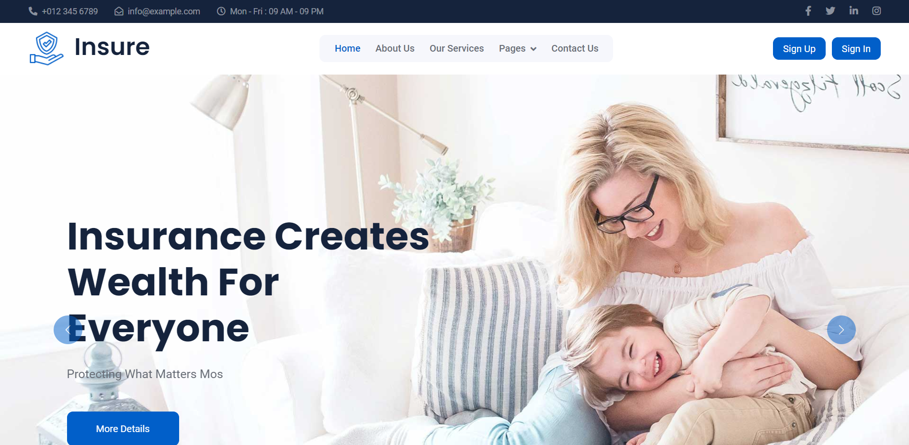

Home page is the first page of a website, designed to give an overview of the site and direct users to other content on the site. It usually includes navigation menus, product or service information, breaking news, social media shares, and links to other pages on the site. The purpose of the Home page is to introduce the site and direct the user to other content on the site. In addition, the Home page may contain promotional images or images to showcase the website's products or services.

**3_About Us Page:**

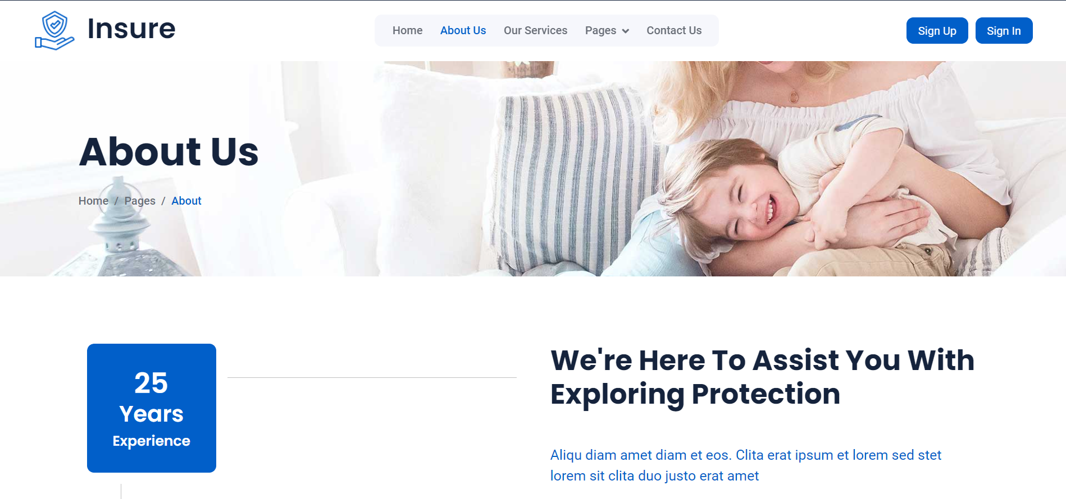

The About Us page is an important page of a website that introduces that website. It contains information about the organization's history, mission, core values, and staff. The purpose of the About Us page is to introduce the organization to customers, helping them better understand our products and services. The content on the About Us page is often written in the form of passionate words, to describe our passion and love for our products and projects. The About Us page may also contain information about social activities and community contributions. It may also contain photos or videos to showcase our projects and products.

**4_Our Sevices Page:**

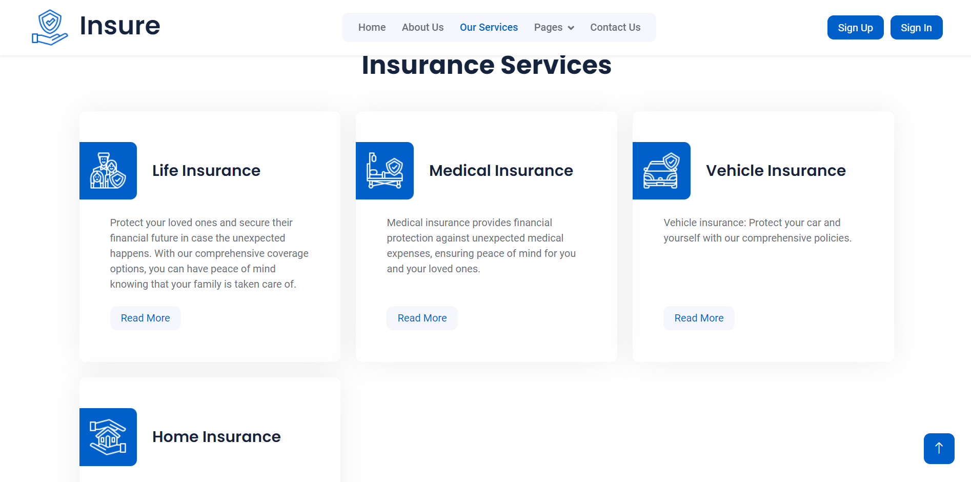

The Our Services page is an important part of the website, showcasing the organization's products and services to customers. It provides detailed information about products and services along with information on prices and offers. The Our Services page may contain photos or videos that showcase the organization's products and services. It may also contain customer reviews or comments about the organization's products and services. The purpose of the Our Services page is to introduce the organization's products and services to customers, help them better understand the organization's products and services, and be able to evaluate and select products and services. fit their needs.

**4_Contact Us Page:**

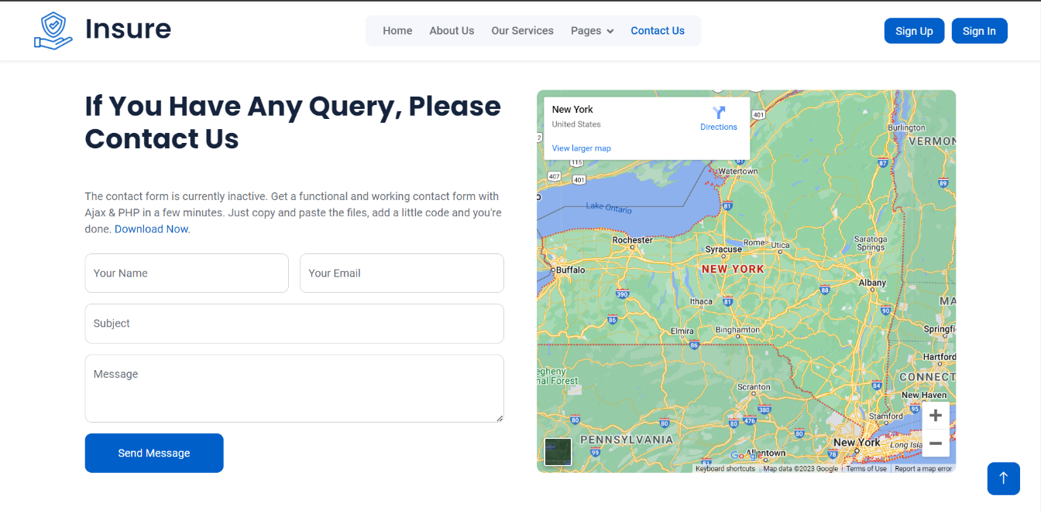

The Contact Us page is an important page on the website, allowing customers to contact the organization or company to solve problems related to products and services. Websites often provide information about an address, phone number, email, and contact form so customers can submit questions or request support. The content on the Contact Us site is designed to be easily accessible and effective, including frequently asked questions and instructions on how to contact the organization or company. The Contact Us page can link to social networking sites so customers can interact directly with the organization or company.

**5_Insurance Admin:**

*\*Dashboard*

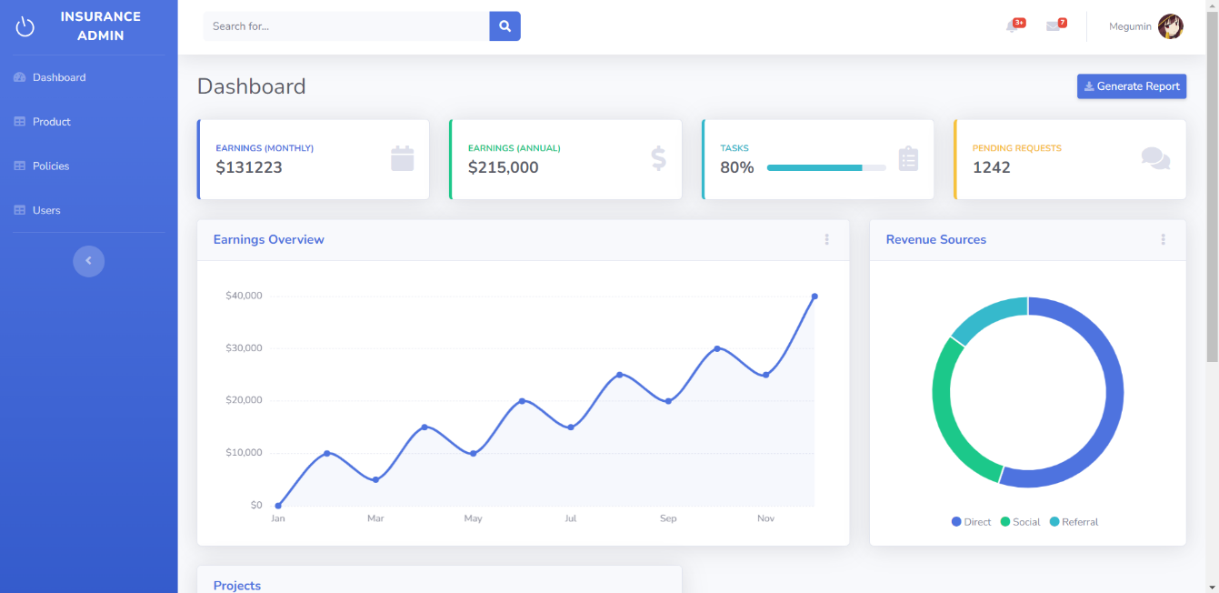

The Insurance Admin page is a professional and convenient insurance management platform, designed to help managers and insurance employees manage and process information related to insurance policies in a timely manner. effective. This website provides essential management features and tools to help insurance managers perform policy management tasks, including adding, modifying, or deleting insurance policies. In addition, the site also offers account management features, overview reports, insurance partner tracking, and payment and reimbursement related features. This website integrates leading security technologies and standards to ensure that insurance information is stored and handled safely and securely.

*\*Product*

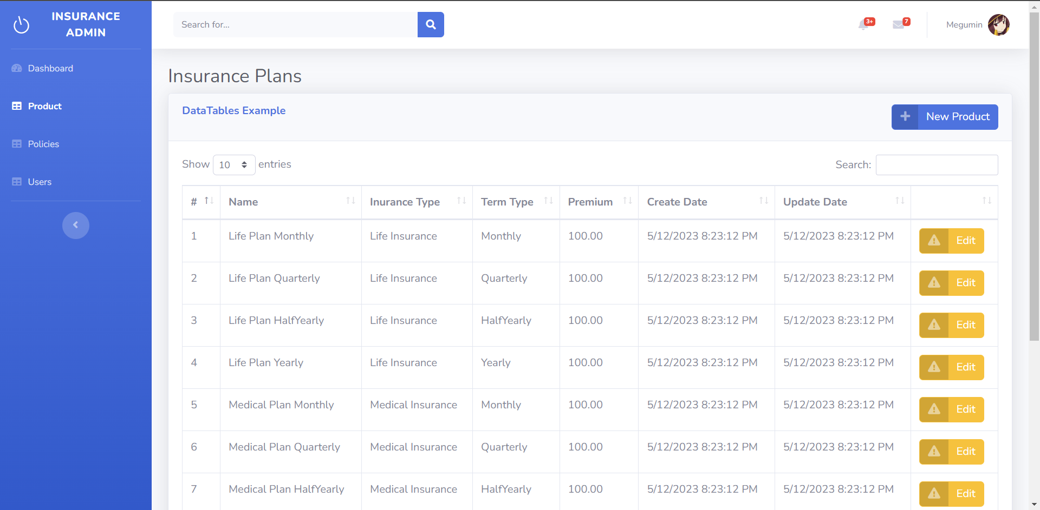

The Product Manager page is a product management tool used by businesses to manage their products. This website provides product managers with a simple and easy-to-use management interface that allows them to manage product information, pricing, inventory status, ordering and shipping. . The site also gives product managers the ability to track sales trends and customer feedback so they can improve the quality of their products and services. In addition, the Product Manager page also provides customization and integration features to help businesses customize and integrate this product management page into their systems easily. In short, the Product Manager page is a useful tool to help businesses manage their products effectively and save time.

*\*Policies*

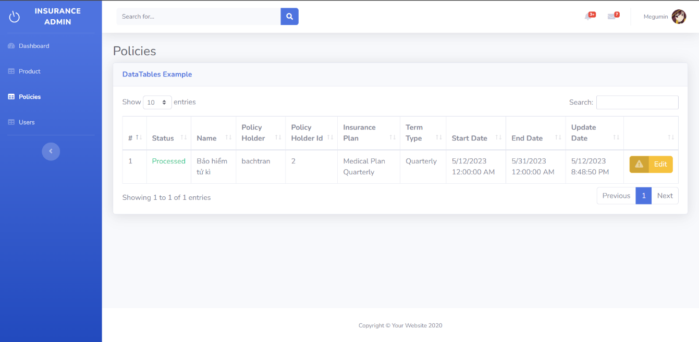

The Policies Manager page is a policy management tool used by businesses to manage their policies. This website provides policy managers with a simple and easy to use interface to manage insurance policies, internal regulations and other policies related to HR management. The Policies Manager page also offers customization features so businesses can customize their policies easily. Besides, the Policies Manager page also allows users to manage policies remotely, from anywhere and at any time. In addition, this website also provides users with the ability to monitor new policies and policy updates. In short, the Policies Manager page is an effective policy management tool that helps businesses manage their policies easily and save time.

*\* User*

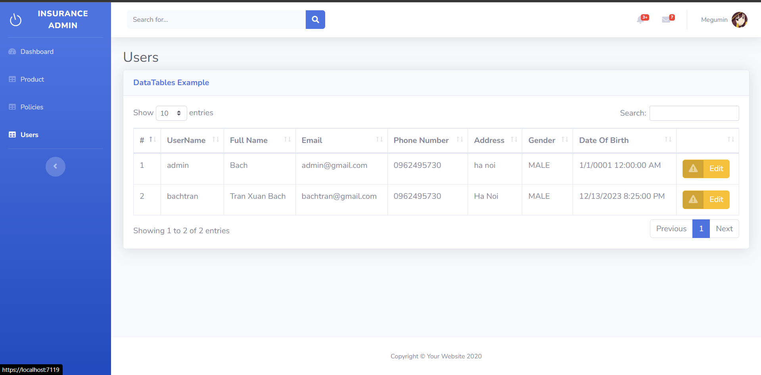

The User Manager page is a user management tool used to manage user information and assign access rights on websites. This website provides administrators with a simple and easy-to-use interface to manage user information, including name, email, password, and authorize access to website features. In addition, the User Manager page also provides the ability to search and filter users by criteria such as name, email, and permissions. Administrators can also add, delete or modify user information as needed. Besides, the User Manager page also allows users to perform operations such as resetting passwords, enabling or disabling user accounts. In short, the User Manager page is a convenient and effective user management tool that helps administrators manage user information quickly and easily.

**6_User Interface:**

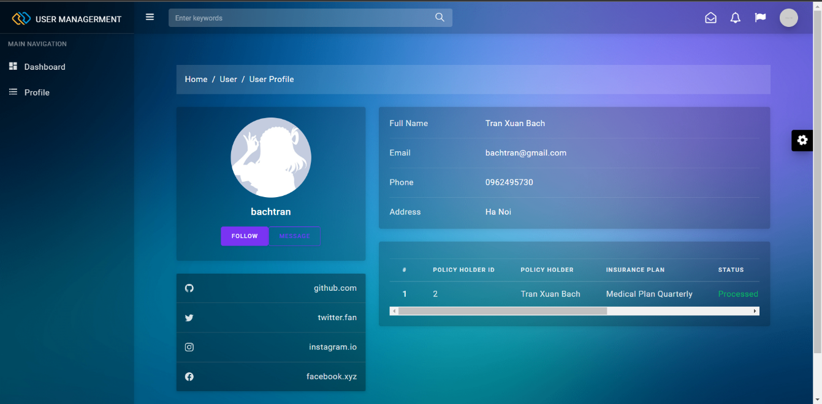

The User Interface page is a website that provides users with an intuitive and easy-to-use interface to interact with the website. User interface pages are usually designed to meet the needs of users, with the aim of making it easy and convenient for them to find, access and use website features. This website has interface features suitable for all types of users, including navigation buttons, input fields, function buttons, and illustrations. The user interface is designed to be simple, intuitive and friendly, making it easy for users to find the information they need and use the site's features efficiently. In addition, the user interface page provides users with options to customize the interface to meet the needs of each user.

Above are some of the pages included in our project, there are many more interesting parts in the project. We invite everyone to pay attention!

**Ending**

After creating the insurance web report, I am truly grateful for the new security technologies and solutions we have adopted to protect information. of users in these important areas.

I am impressed with the efforts of the security team members to help keep medical information, life insurance information, vehicle and home related information safe. This information is very important and sensitive, and protecting it requires special and serious attention from service providers and regulators.

However, the report also shows that there are still many challenges to overcome in protecting users' personal information in these areas. I hope that in the future, our team members will continue to look for new and effective solutions to these challenges, while creating a safer and more trusted online environment for everyone.

Thank to Mr. Hoang Nguyen Duc and the training department for supporting us to complete this project. Thank you Aptech for allowing us to be exposed to the above project to improve our knowledge and practice

Thanks

For

Reading!